**User Story 1: Create main page for Performance UI test**

As a user, I want to have a page to manage the Performance test:

* Have a button to create a new test.
* After created, all tests will display as a list on the Performance UI Testing main page with a run button to allow user to run from the main page and an icon to indicate about shared status.
* Click on a test to display details with saved configuration and history **(Details on Story 3, 4, 5)**

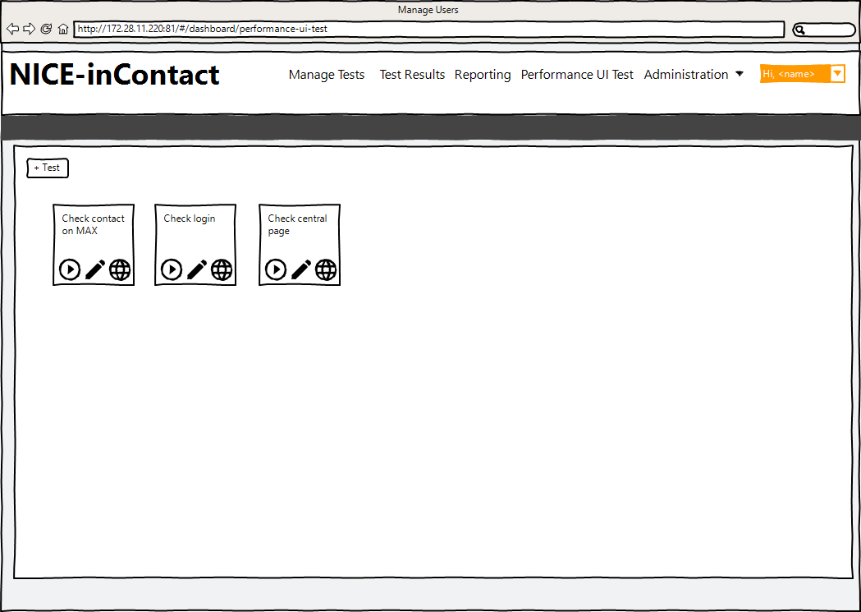

(US 1)

**User Story 2: Create a test and set up the configuration**

As a user, I want to have a form to create a test and set up the configuration with below information:

* Test name.
* Test case to execute (enter test case name or select pre-defined test case).
* Slider and textbox to change the number of instances, maximum is 1000.
* Combo box to select instance type (t2.medium, t3.medium…).
* Checkbox to terminate instances after execution completed. If not check, enable below form.
  + Enter number (minutes) to terminate after time out. If leave blank, displaying a warning that it will cost a lot of money if keeping the instance running.
* Checkbox to run test right after the instance is loaded or wait all instances are started.

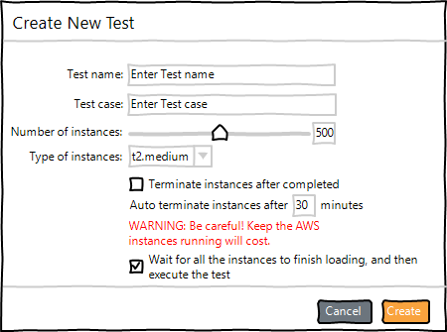

(US 2)

**User Story 3: A general page displays the overview of the test**

As a user, I want to have a general page to show the overview of the test:

* Located on the left
* Have below elements:
  + Name of the test
  + Icon to change name
  + Icon to indicate who is shared and Share test options **(Details on Story 9)**
  + Toggle to send email after done a button to show a dialog to enter email addresses.
  + Number of instances (Show number get from Configuration page)
  + Run/Stop button
  + Terminate all instances (disable if user not select to terminate after execution completed)

**User Story 4: Test detail page to set up the configuration**

As a user, after creating the test, I want a page to display all configurations:

* Configuration on the right
* On the Configuration tab should have below elements:
* Slider and textbox to change the number of instances, maximum is 1000
* Instance type combo box (t2.medium, t3.medium…)
* Checkbox to terminate instances after execution completed. If not check, enabled below form.
* Enter number (minutes) to terminate after time out. If leave blank, display warning that it will cost a lot of money if keep the instance running.
  + Checkbox to run test right after the instance is started or wait all instances are started
  + Advanced collapsible panel to show more feature of load test **(Details on Story 6)**

**User Story 5: More options for load test**

As a user, I want to configure more options to perform load test:

* Enter waiting period of time to start a number of instances in a table with columns:
  + Waiting time before starting more instances
  + Number of instances to start more

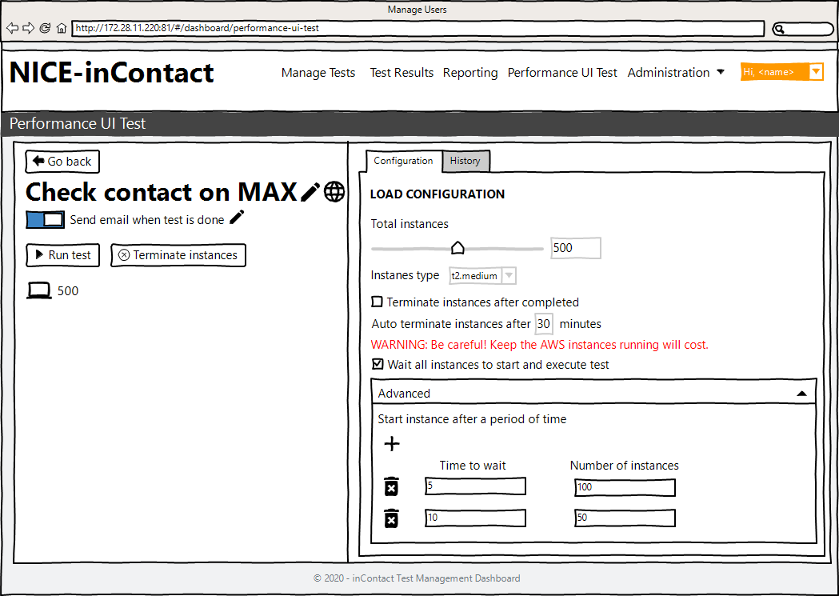

(US 3, 4, 5)

**User Story 6: Test detail page to show the history**

As a user, after creating the test, I want a page to display all configurations:

* History tab on the right same as configuration tab
* On the History tab should have below elements:
  + A table displays with columns:
    - Group ID
    - Number of Instances
    - Status (Starting, running, finished)
    - Start time, End time, Duration
    - Number of Passed, Failed, Success Rate (in percentage)
    - Action (Show details) **(Details on Story 8)**
  + Chart to show the Passed rate of all tests, can change the time frame.
  + Estimation costs for this test **(Details on Story 7)**

**User Story 7: Calculate the estimation cost**

As a user, I want to know the cost when executing the performance testing:

* Calculate the cost based on number of instance, instance type and total running time of an instance
* User can select the time frame to show the total cost: 1 day, 1 week, 1 month, or custom time.

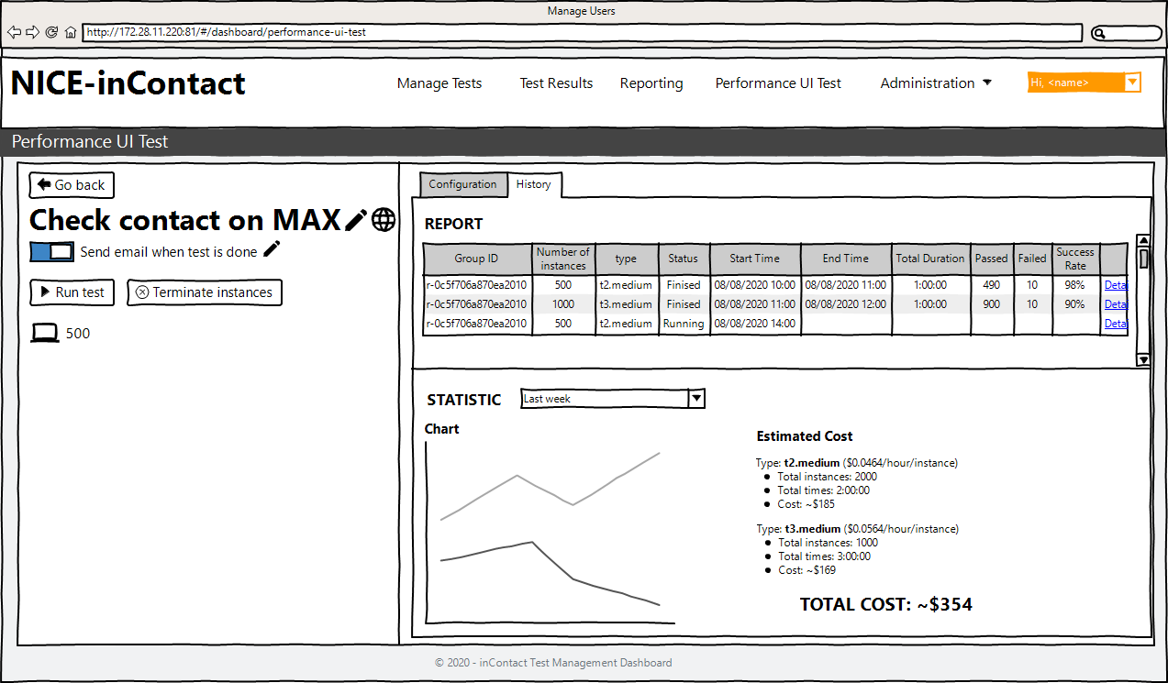

(US 6, 7)

**User Story 8: Click on show details to display details of each execution**

As a user, I want to click on show details to display details of each execution:

* Name of the Group
* Details of test: Cluster, Browser
* Start Time, End Time, Duration
* Instance type
* Passed, Failed, Rate
* Table that shows all instances:
  + Instance IP
  + Status (Starting, Running, Finished)
  + Process that updating in real time (Ex: Step 1: Navigating to …, Step 2: Logging in…)
  + Screenshot of the last steps for both failed and passed
  + Log for all steps of the tests

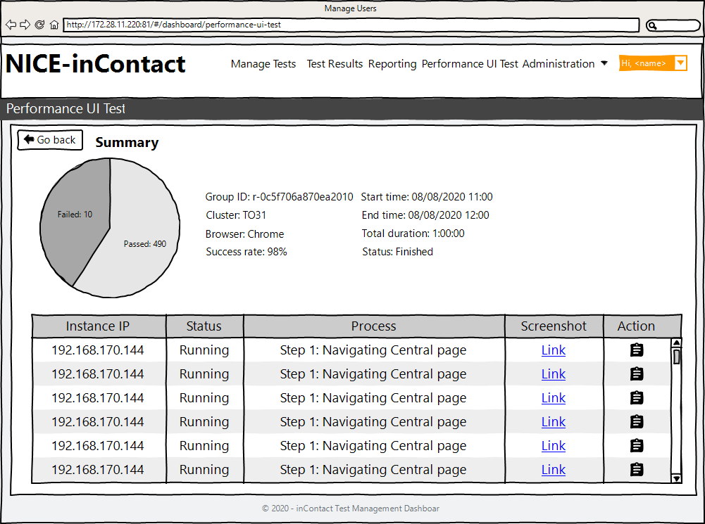

(US 8)

**User Story 9: Share tests**

As an Admin user, I want only ones those I shared the test to can use it for running performance test:

* Set the test as Public so anyone can run it
* Set the test as a Group so anyone in group can run it
* Set the test as a specific name so only ones can run it
* Set the test as private so only the one who create can run it

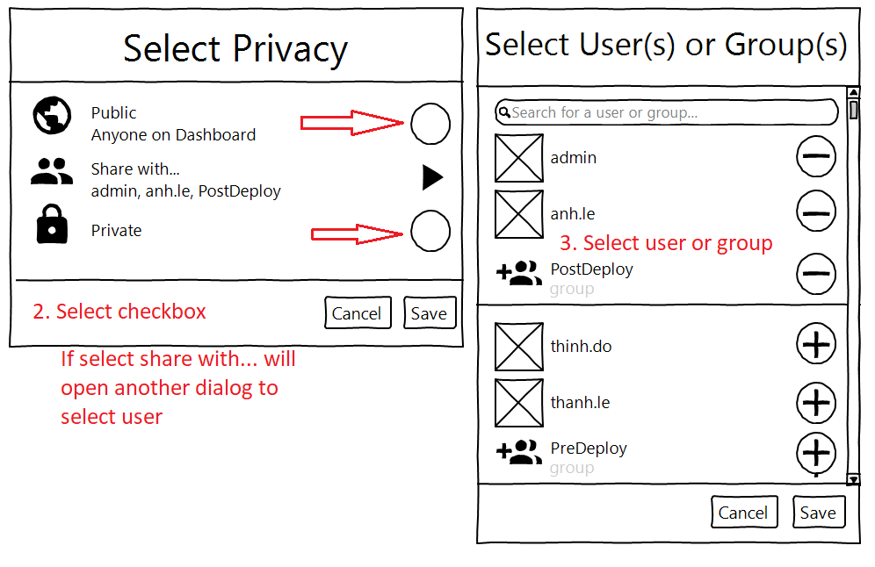

(US 9)